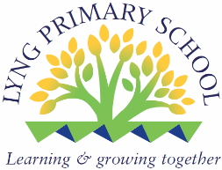
Maths Policy

INTEND
This policy is underpinned by the school’s mission statement: Learning and Growing Together.

Rationale
At Lyng Primary, our intent is to develop a deep understanding, confidence and competence in Maths for all pupils. We take the mastery approach to Maths teaching by following the White Rose Maths motto of ‘Everyone Can Do Maths: Everyone Can!’ and there is no such thing as anyone who can not do Maths. We aim to create a culture that produces strong, secure learning with real progress. We aim to give children the right support, guidance and resources so that all children can become confident and competent mathematicians.
We are creating happy, resilient mathematicians who relish a challenge as well as understanding the important of Maths in everyday life by supporting our children in becoming independent thinkers, reasoners and problem solvers.

Aims
In our teaching of mathematics at Lyng Primary School, the aim is for all pupils to have equality of opportunity. As a result of our Maths teaching at Lyng, you will see:
- children who have a love for Maths
- children who enjoy being challenged.
- lessons that use concrete manipulatives to show the structure behind the maths.
- confident children who are flexible with their approaches to different maths concepts.
- children who can confidently talk about their Maths work and explain their mathematical thinking.
- lessons that allow all children to progress by using an enabling and extending approach.
- lessons that show fluency, reasoning and problem-solving.
Objectives
- Ensure that all pupils follow a broad and balanced mathematics programme based on the requirements of the National Curriculum.
- To ensure that all pupils are provided with interesting and challenging tasks that enables them to achieve standards in line with their abilities and potential.
- To ensure that pupils can work individually, collaboratively in groups and within the whole class.
- To allow pupils to develop as independent learners, able to make decisions about their own work

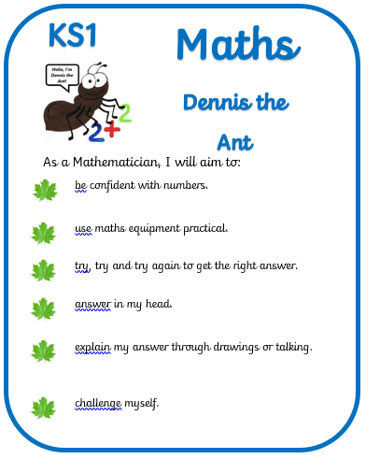
Our Maths Curriculum is designed to allow pupils to develop the following key characteristics:
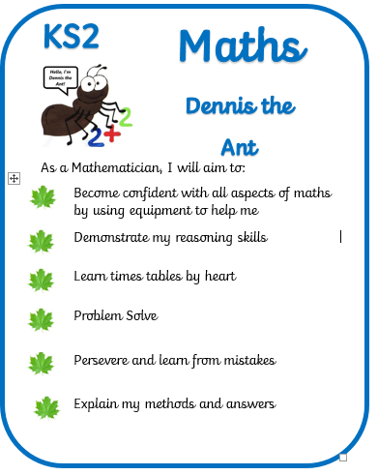

Strategies for the teaching and learning of mathematics at Lyng Primary School
At Key Stages 1 and 2, (25-30%) of the curriculum time is allocated to Mathematics, including links with other subjects.
The maths curriculum will include a full range of mathematical activities covering all aspects of the subject including; number, measures, shape and space and handling data. Using and applying mathematics will be integrated throughout the scheme of work as lessons include practical, investigational, problem solving and oral activities.
The school believes that its teachers collaborate and share good practice to plan, deliver and moderate the teaching of Maths in order to ensure that expectations are high and that children are able to achieve to the best of their ability.
Lessons will have clear learning objectives, (WALT) that are communicated to the pupils. The focus is on direct teaching that is oral and interactive.

Progression Policy for mental or written calculation
The staff at Lyng Primary School follow the White Rose Hub scheme and have developed a separate policy for written calculations (which ties in with that of the scheme).
Aims
The pupils at Lyng Primary School should be able to choose an efficient method, mental or written appropriate to the task.

General Progression
- Establish mental methods, based on a good understanding of place value
- Use informal jottings to aid mental calculations
- Develop use of empty number line to help mental imagery and aid recording
- Use partitioning and recombining to aid informal methods
- Introduce expanded written method
- Develop expanded methods into compact standard written form

Early Years Foundation Stage
Children in Nursery and Reception plan and deliver sessions in line with ‘Development Matters,’ following the developmental age bands as guidance and working towards the Early Learning Goals (GLD), The Early Years’ curriculum is linked broadly to themes and to the children’s interests.
The children learn through whole class teaching and small group activities. The activities are differentiated by ability; according to statements within the age bands and working towards the E.L.G statements. Mathematical Development is approached through a variety of activities including; stories, songs, games and imaginative play. Children also develop mathematical skills through child-initiated play where adults link learning and extend their play. Activities at the beginning of the year are mainly practical based and recording is carried out using photographic evidence and a combination of incidental and long observations.
As the year progresses, more advanced elements of mathematics are taught that continue to be matched to the children’s abilities. Teacher led activities are carried out in small groups on a daily basis.
Over the course of Nursery and Reception the following skills will be developed:

- Appropriate mathematical language.
- Making comparisons
- Sorting
- Understanding one to one correspondence
- Conversation of number
- Recognition of numbers (up to 20)
- Writing numbers correctly(up to 20)
- Basic use of estimation
- Naming and describing basic 2D and 3D shapes
- Copying and recognising patterns
- Early use of conventional time units
- Early use of non-standard and standard measures
- Early use of appropriate IT
- Addition and subtraction
- Doubling and halving
- Money
- Counting in 2s, 5s and 10s.
Key Stage 1 and Key Stage 2
Children are in mixed ability classes for all their maths lessons. Lessons are planned for using the White Rose Scheme. At Lyng, we are following the CPA approach so lessons consist of planned CONCRETE task (manipulatives), PICTORIAL formations (drawings) and ABSTRACT work (numbers/digits).
Children also have an extra 30 minute maths session on a Monday morning which is a focused athematic session (mental maths Mondays). In this lesson children can practise number bonds, times tables, number facts, written methods, percentages, etc.
Mastering Number for EYFS and KS1
The Mastering Number Programme for Reception and Key Stage 1 (KS1) aims to secure firm, early foundations in mathematics by developing pupils' good number sense, fluency, and flexibility with numbers. These sessions are short sharp bursts of focused mathematics that take place 3-4 times a week during the afternoon session of the school day. It focuses on key skills like subitising, composing/decomposing numbers, and using manipulatives (such as rekenreks) through daily, short, evidence-based sessions to improve confidence and reduce procedural approaches to math.
Mastering Number for KS2
The Mastering Number at KS2 programme, focuses on Years 4 and 5. It aims to develop solid number sense, fluency, and automaticity in multiplication and division facts. It enhances pupils' confidence and flexibility with numbers, strengthening their understanding of multiplicative relationships—a critical foundation for success in secondary school mathematics. These sessions are short sharp bursts of focused mathematics that take place 3 times a week during the afternoon session of the school day.
Planning
- Medium term plans – each year group will be given an overview of the units to be covered each term and the approximate length of time spent on each unit from the White Rose Scheme of work. However, we scaffold our learning to the needs of our learners so this is a guideline and staff make their own judgements if more/less time is needed.
- Weekly Smartborads are created to help the maths learning journey. The Maths subject leader will monitor the planning on specific Wednesday afternoons alongside a selection of books across the year groups.

Resources and manipulatives
Resources and manipulatives play a huge part during maths lessons at Lyng. They are overseen by the mathematics lead. The role of the Maths subject leader is to support the Maths curriculum. Resources and manipulatives are stored in the classrooms with a small amount of equipment stored centrally (year 3 middle area). The subject leader will complete an audit of resources at the start of each academic year. Standards funding for training is also available to support the CPD of all staff.
Marking
Marking will be carried out daily and in accordance with the school’s marking policy (live marking is expected in maths lessons).
EYFS Assessment
Children are assessed throughout the year during child initiated and teacher directed activities following early year’s assessment policy.
KS2 and KS2 Assessment
Children are assessed termly through the White Rose scheme. They complete a COLD assessment at the start of each term and then complete the same assessment at the end of each term once all the teaching and learning has took place, better known as a HOT assessment. The progress from the COLD to HOT is monitored and analysed. This feeds into the school’s assessment system which gives each child an overall academic level.
Daily Assessment
In the short term, teachers will carry out continuous assessment of children’s progress in all aspects of the Maths Curriculum. The temperature is taken at the start of every maths lesson and the end. Children and teachers alike can see how much progress has been through the temperature and imindtae intervention can take place. Teachers also develop the use of peer and self-assessment with systems such as WWW (what went well) and EBI (even better if) against the WALT and Success Criteria.

Assessment and Moderation
Children’s progress in Maths is assessed through success criteria in lessons with the progress against these informing the feedback of that child’s work. In addition to this at the end of every term the class teacher is expected to upload judgements of their progress and attainment to the SIMS tracker. Progress and retention of knowledge is monitored through regular quizzing and revisiting skills and vocabulary through the word wallets in every classroom.

Children are assessed as one of the following:

Code | Meaning | Support
U | Unable to assess | Not sufficient evidence to make a judgement.
E | Emerging | Heavily scaffolded – accessing the objective with resources.
D | Developing | Uses age appropriate scaffolding.
S | Secure | Independent application.
M | Mastered | Application outside the lesson independently.

Moderation of Maths work occurs on a termly basis.
Topic Mathematics Links
Learning skills may be developed across the curriculum. Examples include measuring in technology, charts and graphs in science and geography, time and dates in history, patterns in art, music and dance, scoring and counting in physical education. Skills such as listening, speaking, interpreting and questioning, hypothesising, etc will be integrated into the daily mathematics lesson.
This helps to expand and consolidate mathematical concepts and using maths in a purposeful way in everyday contexts and helps the children to realise that mathematics is important in the real world.
Teachers are expected to teach 2 cross curricular maths lessons per term. This will be monitored by the Maths co-ordinator.
Homework
Weekly homework is set via Mirodo in accordance with Lyng Primary School’s home learning policy. Home learning activities may include:
- Learning of multiplication tables
- Pre learning for upcoming topics
- Post learning to support retention of learning coveredin class
- Extra practice of calculations taught during the week.

Dennis the ant is our Maths expert

As chosen by the School Council, Dennis the spider is our expert in all things maths. Our Lyng Learning Animals allow the children to access learning in a fun and engaging manner.

Role of The Maths Subject leader
To plan for and sustain development and improvement in the teaching of learning of mathematics.
- Lead/organise staff development
- Ensure continuity and progression through monitoring of planning, book, and lessons.
- Support the development of record keeping, assessment and target setting systems in mathematics.
- Disseminate good practice.
- Analyse data from termly assessments and highlight no progress or slow movers for intervention.
- Monitor, order and organise maths resources.
- Keep up to date with developments in maths. Disseminate to others.
- Inform Headteacher and Maths link governor of issues affecting mathematics within the school.
Equal Opportunities
There is a school equal opportunities policy, which is applied to mathematics. Teaching materials are chosen to reflect the cultural and ethnic diversity of our society. At Lyng Primary School we try to avoid stereotyping through gender or race. Pupil’s performance is monitored to ensure that no group of pupils is disadvantaged. In lessons, the full participation of both girls and boys is encouraged and care is taken to ensure that the emphasis on whole class teaching does not disadvantage any gender.
Health and Safety
In line with the schools health and safety policy, children are instructed in the use of all equipment. If children are working outside the classroom they are supervised, especially during cooking and more practical activities. Children will be taught how to use potentially dangerous equipment in a sensible manner e.g. scissors, pair of compasses, weights.
Parental Involvement
A leaflet has been completed to support the calculations policy and will be reviewed. The parents are informed of the targets at parent’s evening. Where appropriate, open meetings are planned to encourage parents to learn the methods of calculations used in mathematics lessons at Lyng. The Maths leader will host maths sessions for parents throughout the year to explain the Written Methods and expectations in maths for the three phases. Year 1 and 2, Year 3 and 4 and Year 5 and 6.

Monitoring and Evaluation
Staff will review this policy and the Full Governing Body will be informed.
The Headteacher reporting to the full Governing Body will evaluate progress.
Reviewed November:_____________

Next Review Date:_______________

